

Laboratory Record
  - CSE4001 - Internet and Web Programming
Interim Semester: 2025-26
Slot: A21+A22+A23+B22+C14+D21
Class Number: BL2025260400043

Prajwal Pal - 22BCE10643
Ruchita Mahajan - 22BCE11471
Pranjali Shrivastava - 22BCE11114

Index
Exp. No. | Name of the Experiment | Page #
1 | Analyze the existing IRCTC website and improve the website using HTML
2 | Design an English alphabet chart such that on clicking the alphabet the appropriate  example must be displayed using HTML client-side image mapping
3 | Design the online periodic table as follows using CSS
4 | Validate the ISBN number of a given book using regular expressions
5 | Develop tic-tac-toe game using JavaScript
6 | Develop an online application to find the transpose of the given matrix. Obtain the  number elements from the user based on the number of rows and columns using  JavaScript
7 | Create a hospital registration form and validate the fields using JavaScript
8 | Develop a shopping cart application using PHP sessions
9 | Develop an online quiz application using PHP where the questions and answers are  maintained in database
10 | Maintain student details using XML and validate their order using Schema. Let the  first name and last name of the student be grouped. The registration number is an  attribute of student element. The root element is student_details. Student is a  complex element that has department, address and phone number. Apply a  restriction on the phone number such that is in the format of XXX-XXXX where x is an  integer
11 | Perform the following using PERL:  (a) Create an array with 10 elements  (b) Print the highest index of the array  (c) Assign beyond the end of the array, to an element at index 20  (d) Save the current highest index in a scalar, and print it.  (e) Set the array size to 5 elements (index 4)  (f) Print the array  (g) Set the array size back to the previous size (using the scalar created in (d)). (h) Print the array

Exp No: 1 | Analyze the existing IRCTC website and improve the website using HTML
Date:

Aim: Create a simple UI mock for an IRCTC booking page with form fields and service cards.
Objective / Algorithm:
- Build a basic HTML booking form (from station, to station, date, class) and add a submit button.
- Provide service cards and links; the form is a demo without backend.
Program:
```
<!-- file: irctc/index.html -->
<form>
<input type="text" placeholder="From Station" />
<input type="text" placeholder="To Station" />
<input type="date" />
<select><option>Sleeper (SL)</option></select>
<button type="submit">Search Trains</button>
</form>
```
Output: 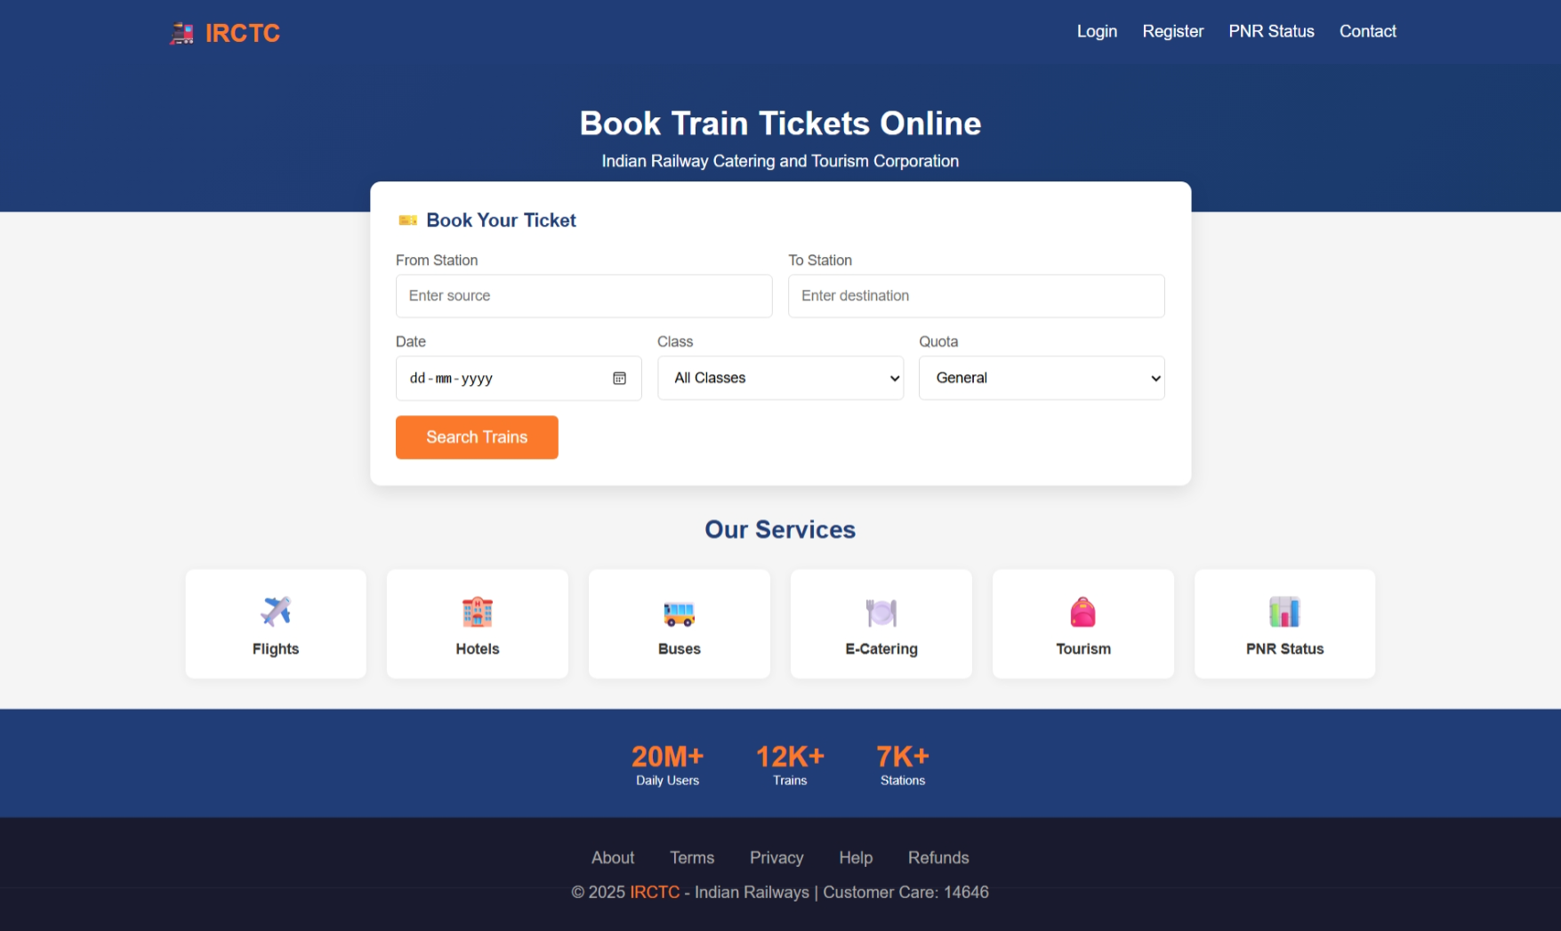
Result: Thus the program is executed and output is verified.

Exp No: 2 | Design an English alphabet chart such that on clicking the alphabet the appropriate  example must be displayed using HTML client-side image mapping
Date:

Aim: To create a client-side A–Z flashcard display using a custom element; front shows the letter, back shows the word and optional image.
Objective / Algorithm:
- Define a custom element flip-card (web component) to render front/back and add click/flip behavior.
- Prepare a data array for letters A–Z with words and optional images.
- On DOM load, iterate the array and create flip-card elements with attributes set.
- Ensure accessibility and progressive enhancement (content fallback if JS disabled).
Program:
```
// file: abc/script.js (key parts)
class Card extends HTMLElement {
connectedCallback() {
const front = this.getAttribute('front');
const para = this.getAttribute('para');
const image = this.getAttribute('image');
// markup for front/back and image
this.innerHTML = `...`;
}
}
customElements.define('flip-card', Card);

const alphabet = [{letter:'A',word:'Apple'}, /*... Z */];
function buildAlphabetGrid() {
const grid = document.querySelector('.grid');
alphabet.forEach(entry => {
const el = document.createElement('flip-card');
el.setAttribute('front', entry.letter);
el.setAttribute('para', entry.word);
el.setAttribute('image', `./public/${entry.letter.toLowerCase()}.jpg`);
grid.appendChild(el);
});
}
document.addEventListener('DOMContentLoaded', buildAlphabetGrid);
```
Output: 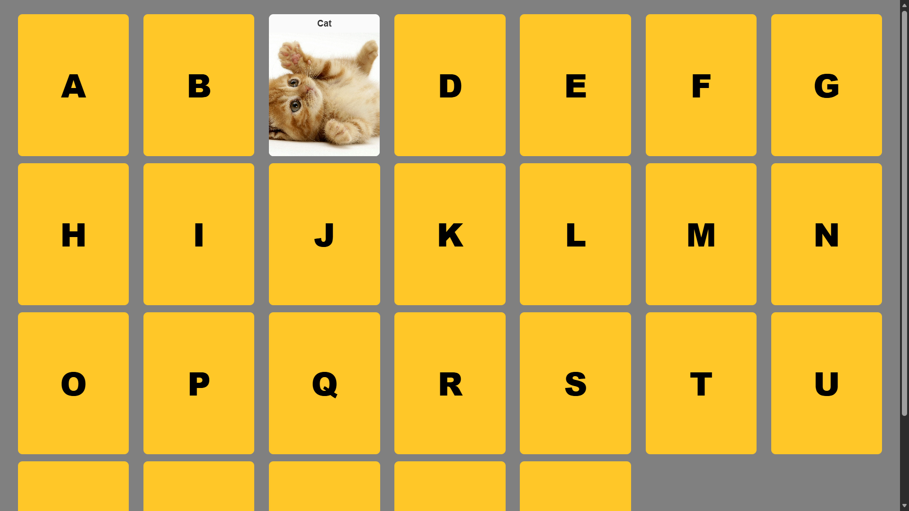
Result: Thus the program is executed and output is verified.

Exp No: 3 | Design the online periodic table as follows using CSS
Date: | Design the online periodic table as follows using CSS

Aim: Render a clickable periodic table grid with element cards and details.
Objective / Algorithm:
- Use a custom web component element-card which presents front/back details.
- Set up a color map for element categories and a list of element data (num,name,mass,config,position).
- Programmatically create cards, position them with CSS grid, and append to .grid.
- On click, open a detail (Wikipedia link) or show additional data in a popup.
Program:
```
// file: elements/script.js (core)
class ElementCard extends HTMLElement {
connectedCallback(){
const num=this.getAttribute('num'), sym=this.getAttribute('sym'), name=this.getAttribute('name');
this.innerHTML = `<div class="card" style="--color:${this.getAttribute('color')}">...</div>`;
this.addEventListener('click', () => window.open(`https://en.wikipedia.org/wiki/${name}`,'_blank'));
}
}
customElements.define('element-card', ElementCard);

const elements = [{num:1, sym:'H', name:'Hydrogen', mass:'1.008', config:'1s¹', color: '#...'}, /*...*/];
const grid = document.querySelector('.grid');
elements.forEach(el => {
const card = document.createElement('element-card');
Object.entries(el).forEach(([k,v]) => card.setAttribute(k, v));
card.style.gridColumn = el.col;
card.style.gridRow = el.row;
grid.appendChild(card);
});
```
Output: 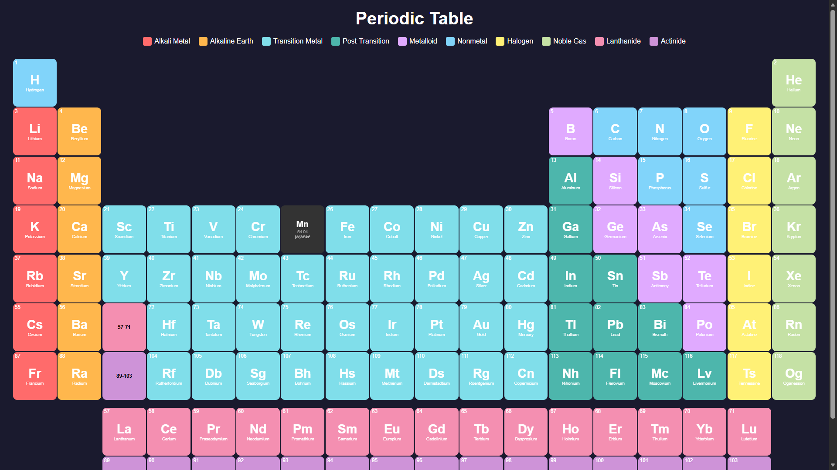
Result: Thus the program is executed and output is verified.

Exp No: 4 | Validate the ISBN number of a given book using regular expressions
Date:

Aim: Validate ISBN-10 and ISBN-13 with checksum and provide user feedback.
Objective / Algorithm:
- Clean input (remove hyphens/spaces) and detect format by length.
- For ISBN-10: compute sum of digits weighted 10..1; allow 'X' as 10.
- For ISBN-13: compute weighted sum alternating 1 and 3; check mod 10.
- Show friendly message and differentiate invalid format vs invalid checksum.
Program:
```
// file: isbn/script.js (complete)
function cleanISBN(isbn) { return isbn.replace(/[- ]/g,''); }
function validateISBN10(isbn) {
const s = cleanISBN(isbn); if (s.length!==10) return false;
let sum=0; for (let i=0;i<9;i++) sum += parseInt(s[i])* (10-i);
const last = s[9].toUpperCase() === 'X' ? 10 : parseInt(s[9]);
sum += last; return sum % 11 === 0;
}
function validateISBN13(isbn) {
const s = cleanISBN(isbn); if (s.length!==13) return false;
let sum=0; for (let i=0;i<13;i++){ const d=parseInt(s[i]); sum += i%2 ? d*3 : d; }
return sum % 10 === 0;
}
function validateISBN(isbn){ const s=cleanISBN(isbn); if(s.length===10) return validateISBN10(isbn); if(s.length===13) return validateISBN13(isbn); return false; }
```
Output: 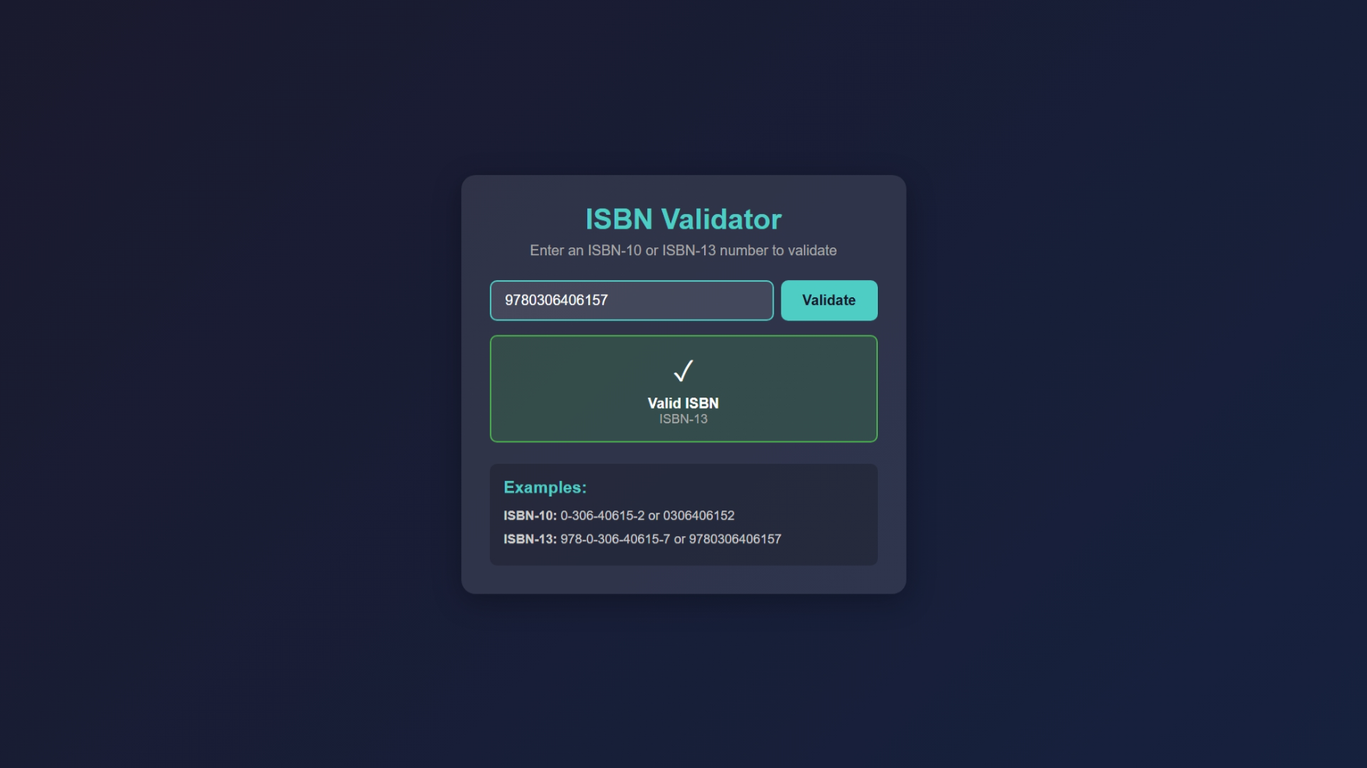
Result: Thus the program is executed and output is verified.

Exp No: 5 | Develop tic-tac-toe game using JavaScript
Date: | Develop tic-tac-toe game using JavaScript

Aim: Implement a client-side Tic-Tac-Toe game with win/draw detection and score tracking.
Objective / Algorithm:
- Set up a 3x3 board data array and initial player X.
- On click, validate move, update board and the UI.
- After each move, check win patterns; if win, mark and update scores; if full board, declare draw.
- Allow game restart and keep scoreboard.
Program:
```
// file: tictactoe/script.js (main)
const cells=document.querySelectorAll('.cell'); let board = Array(9).fill('');
let currentPlayer='X', gameActive=true, scores={X:0,O:0,draw:0};
const winPatterns=[[0,1,2],[3,4,5],[6,7,8],[0,3,6],[1,4,7],[2,5,8],[0,4,8],[2,4,6]];
function handleCellClick(e){
const i = +e.target.dataset.index;
if(board[i] || !gameActive) return;
board[i] = currentPlayer; e.target.textContent = currentPlayer;
if(checkWinner()){ gameActive=false; scores[currentPlayer]++; /* highlight */ }
else if(board.every(x=>x)) { gameActive=false; scores.draw++; }
else { currentPlayer = currentPlayer === 'X' ? 'O' : 'X'; }
}
function checkWinner(){ /* test patterns and highlight */ }
cells.forEach(c => c.addEventListener('click', handleCellClick));
```
Output: 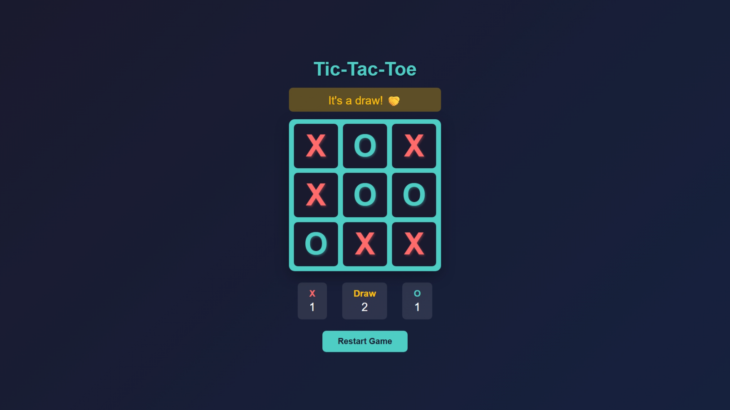
Result: Thus the program is executed and output is verified.

Exp No: 6 | Develop an online application to find the transpose of the given matrix. Obtain the  number elements from the user based on the number of rows and columns using  JavaScript
Date:

Aim: Provide a small UI to build a matrix and compute its transpose.
Objective / Algorithm:
- Take rows & cols inputs; generate matrix input fields with unique IDs.
- Extract the matrix as numbers, compute transpose by swapping indices (m[i][j] -> out[j][i]).
- Render transposed matrix as a table; handle non-numeric/empty gracefully.
Program:
```
<!-- file: transpose/index.html (script part) -->
g = () => { /* build input cells with ids aij using r & c */ };
t = () => {
const r=+document.getElementById('r').value, c=+document.getElementById('c').value;
const m = Array.from({length:r}, (_,i) => Array.from({length:c}, (_,j)=> +document.getElementById(`a${i}${j}`).value || 0));
document.getElementById('o').innerHTML = Array.from({length:c}, (_,j) => `<tr>${Array.from({length:r},(_,i)=> `<td>${m[i][j]}</td>`).join('')}</tr>`).join('');
};
document.addEventListener('DOMContentLoaded', g);
```
Output: 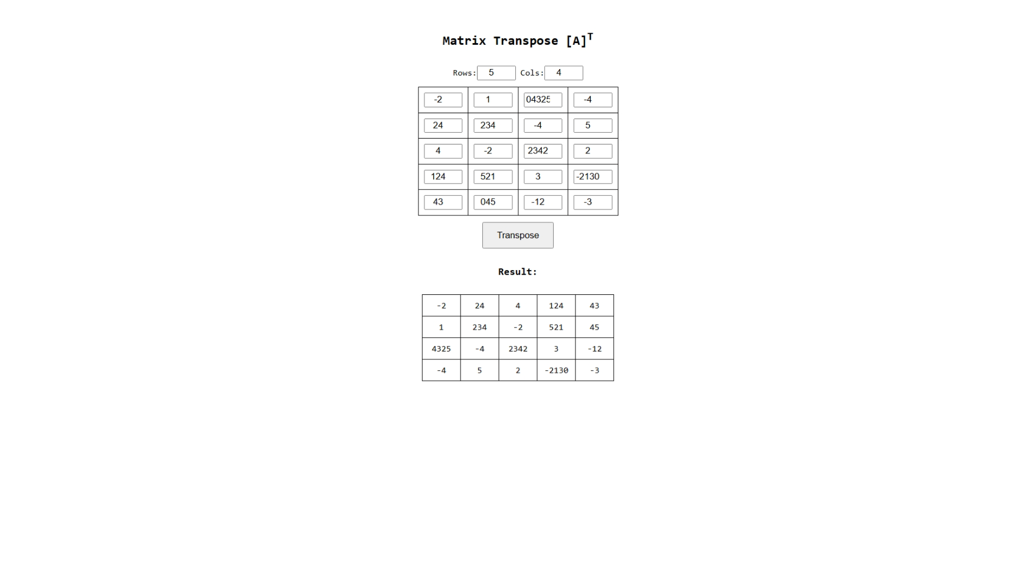
Result: Thus the program is executed and output is verified.

Exp No: 7 | Create a hospital registration form and validate the fields using JavaScript
Date:

Aim: Create a patient registration UI with client-side validation and display.
Objective / Algorithm:
- Build form fields and mark required ones (name, email, phone, DOB, gender, city, emergency contact).
- Implement validators for each field; show contextual errors inline (live validation).
- On valid submit, format the submission into a human-readable summary and reset the form.
- Keep accessibility (aria-live for messages).
Program:
```
// file: AIIMS/script.js (complete flow)
const form = document.getElementById('registrationForm');
const display = document.getElementById('display-data');
// validators object with functions per field
const validators = {
fullName: v => v.trim().length >=3 || 'Name must be 3+ chars',
email: v => /^\S+@\S+\.\S+$/.test(v) || 'Invalid email',
phone: v => /^\+?[0-9 \-()]{7,15}$/.test(v) || 'Invalid phone',
dob: v => { /* validate not future */ },
gender: v => ['Male','Female','Other'].includes(v) || 'Select gender',
// emergency and others...
};
function validateAll() { /* loop inputs and show/clear errors */ }
function displayLatestData() {
if (!validateAll()) return display.textContent='Fix errors';
const patient = Object.fromEntries(new FormData(form));
display.innerHTML = `<strong>Patient Registered:</strong> ${patient.fullName} ...`;
form.reset();
}
document.addEventListener('DOMContentLoaded', () => {
form.addEventListener('submit', e => { e.preventDefault(); displayLatestData(); });
attachListeners();
});
```
Output: 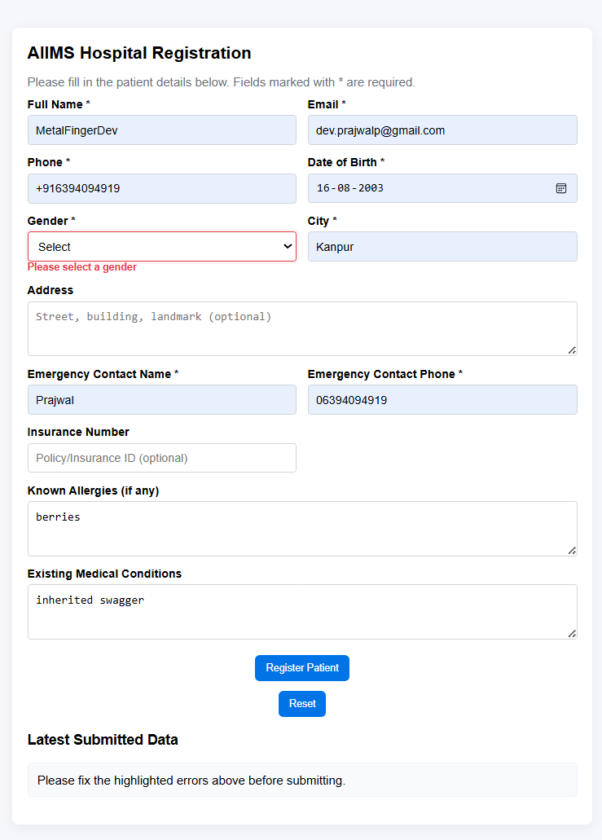
Result: Thus the program is executed and output is verified.

Exp No: 8 | Develop a shopping cart application using PHP sessions
Date: | Develop a shopping cart application using PHP sessions

Aim: Show basic session-based cart operations (add/remove/update/clear) with dynamic totals.
Objective / Algorithm:
- Define product catalog in PHP script; store cart as $_SESSION['cart'] = [id => qty].
- Handle GET actions for add/remove/clear, and POST update for quantities.
- Recompute totals and render cart view or product view depending on action ?action=cart.
- Basic JavaScript updates subtotal/totals before form submit.
Program:
```
<?php
// file: cart/index.php (relevant)
session_start();
$prods = [1=>['name'=>'Apple','price'=>0.50], 2=>...];
$act=$_GET['action']??''; $id=(int)($_GET['id'] ?? 0);
if($act==='add' && $id) { $_SESSION['cart'][$id] = ($_SESSION['cart'][$id] ?? 0) + 1; header('Location:index.php'); }
if($_SERVER['REQUEST_METHOD']==='POST') {
foreach($_POST['qty'] as $pid=>$q){ $pid=(int)$pid; if($q <= 0) unset($_SESSION['cart'][$pid]); else $_SESSION['cart'][$pid] = (int)$q; }
header('Location:index.php?action=cart');
}
function cartTotal($cart,$prods){ $t=0; foreach($cart as $id=>$q) if(isset($prods[$id])) $t += $prods[$id]['price'] * $q; return $t; }
```
Output: 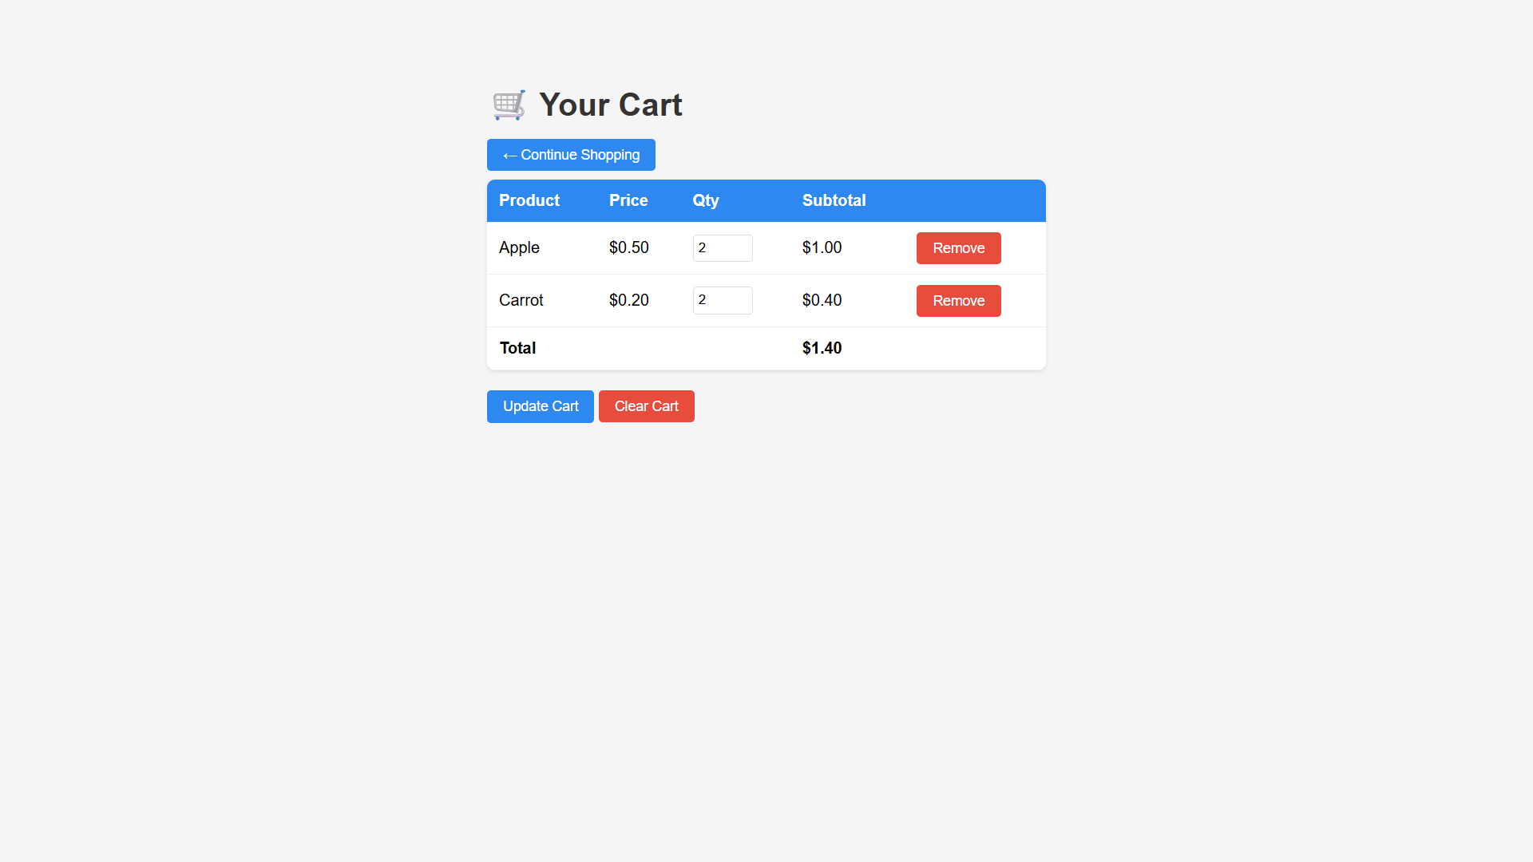 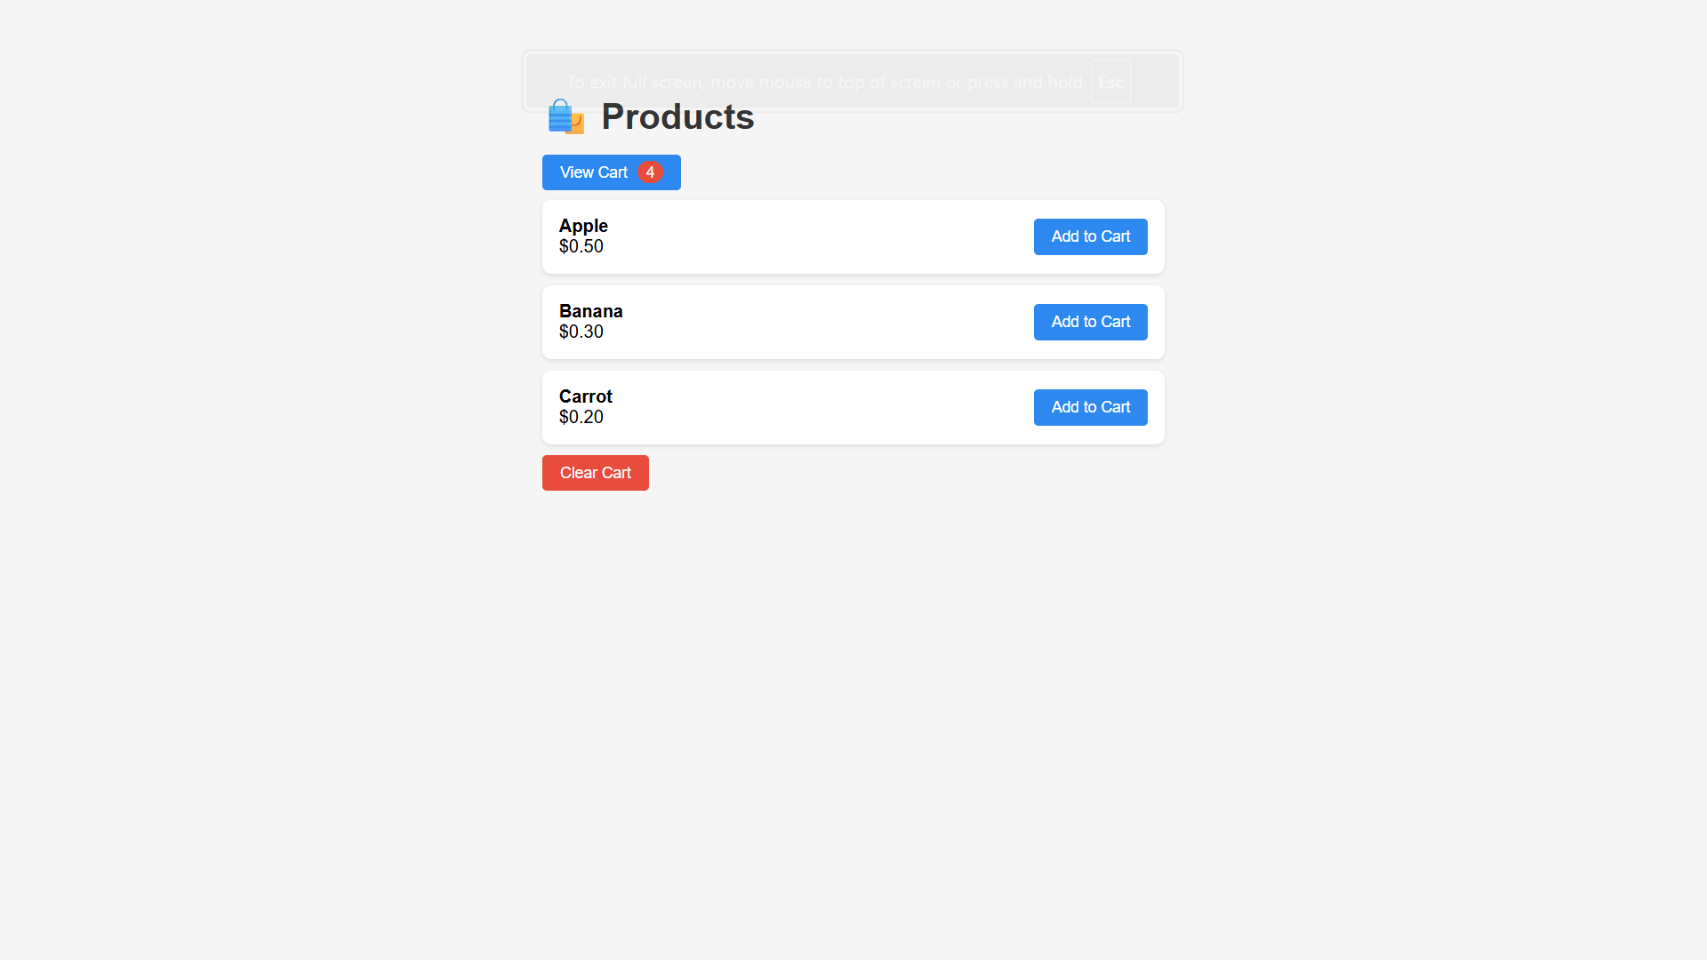
Result: Thus the program is executed and output is verified.

Exp No: 9 | Develop an online quiz application using PHP where the questions and answers are  maintained in database
Date:

Aim: Basic MCQ quiz app with DB-backed questions and session score. Objective / Algorithm:
- config.php connects to database; questions table stores questions/options/correct.
- On start: set $_SESSION['score'] = 0, $_SESSION['current'] = 0. On answer: fetch correct answer, update score, increment current.
- At end: show result, destroy session.
- Include simple UI for question + options form.
Program:
```
<?php
// file: quiz/index.php (key flow)
session_start(); require 'config.php';
if($_SERVER['REQUEST_METHOD']=='POST'){ if(isset($_POST['start'])){ $_SESSION['score']=0; $_SESSION['current']=0; } else {
$r = $conn->query("SELECT correct_answer FROM questions LIMIT {$_SESSION['current']},1"); $row = $r->fetch_assoc();
if($_POST['answer'] == $row['correct_answer']) $_SESSION['score']++; $_SESSION['current']++;
}}
$total = $conn->query("SELECT COUNT(*) as c FROM questions")->fetch_assoc()['c'];
if(isset($_SESSION['current']) && $_SESSION['current'] >= $total) { echo "Score: ".$_SESSION['score']; session_destroy(); exit; }
$q = $conn->query("SELECT * FROM questions LIMIT {$_SESSION['current']},1")->fetch_assoc();
```
Output: 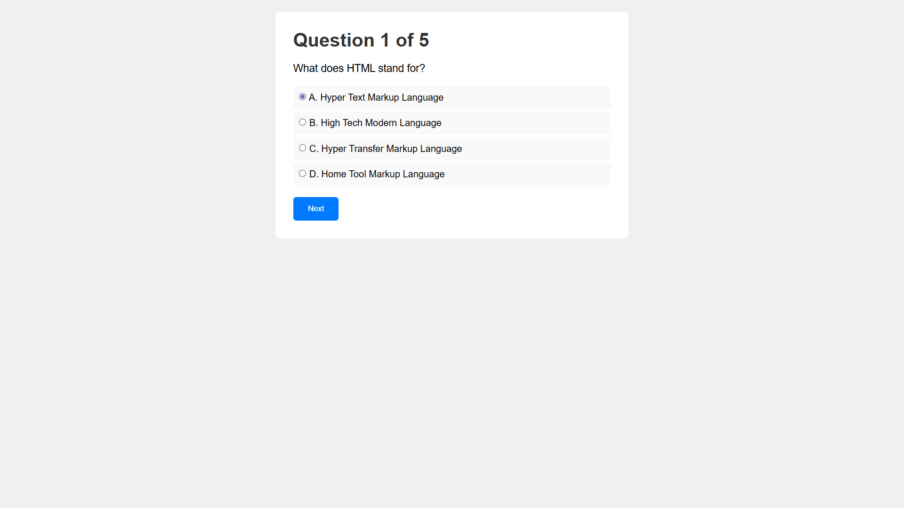
Result: Thus the program is executed and output is verified.

Exp No: 10 | Maintain student details using XML and validate their order using Schema. Let the  first name and last name of the student be grouped. The registration number is an  attribute of student element. The root element is student_details. Student is a  complex element that has department, address and phone number. Apply a  restriction on the phone number such that is in the format of XXX-XXXX where x is an  integer.
Date:

Aim: Design an XML Schema and a sample XML that validates student details with structured sub-elements and attributes.
Objective / Algorithm:
- Define student_details root; student child with name grouping, department, address, phone.
- Add attribute registration_number required; constrain phone with pattern.
- Provide a sample XML (students.xml) that adheres to schema for demonstration.
Program:
```
<!-- students/student_schema.xsd (important parts) -->
<xs:element name="student_details"> ...
<xs:element name="student" maxOccurs="unbounded">
<xs:complexType>
<xs:sequence>
<xs:element name="name"><xs:complexType> <xs:sequence> <xs:element name="first_name" type="xs:string"/> <xs:element name="last_name" type="xs:string"/> </xs:sequence></xs:complexType></xs:element>
<xs:element name="department" type="xs:string"/> <xs:element name="address" type="xs:string"/> <xs:element name="phone"><xs:simpleType><xs:restriction base="xs:string"><xs:pattern value="\d{3}-\d{4}"/></xs:restriction></xs:simpleType></xs:element>
</xs:sequence>
<xs:attribute name="registration_number" type="xs:string" use="required"/>
</xs:complexType>
</xs:element>
</xs:element>
```
Output: 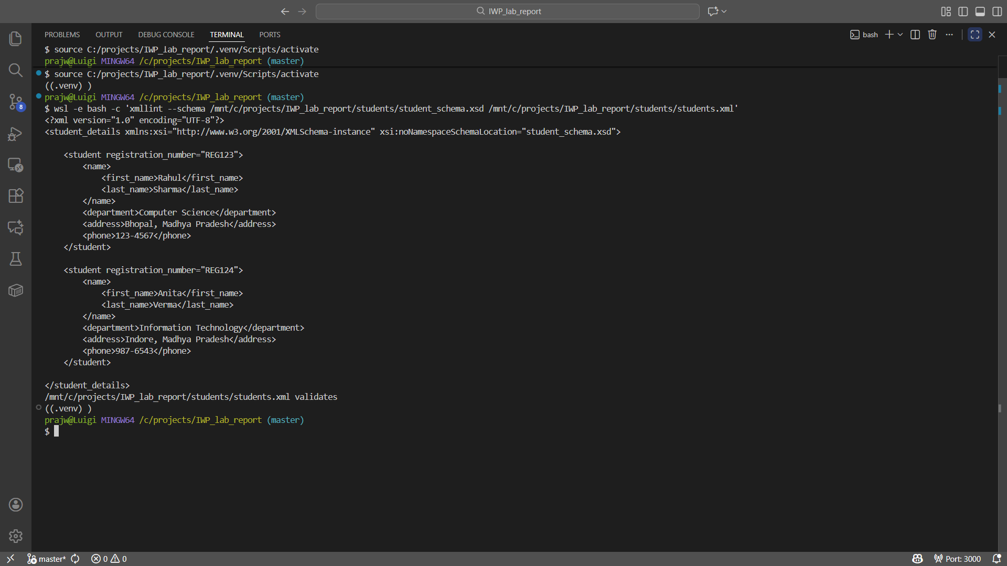
Result: Thus the program is executed and output is verified.

Exp No: 11 | Perform the following using PERL:  (a) Create an array with 10 elements  (b) Print the highest index of the array  (c) Assign beyond the end of the array, to an element at index 20  (d) Save the current highest index in a scalar, and print it.  (e) Set the array size to 5 elements (index 4)  (f) Print the array  (g) Set the array size back to the previous size (using the scalar created in (d)). (h)  Print the array
Date:

Aim: Demonstrate array resizing (+index beyond end) and restoring size in Perl.
Objective / Algorithm:
- Create array with 10 values; show highest index.
- Assign a value at index 20 to expand; store highest index to scalar.
- Truncate array to size 5 using $#arr = 4; print indices and values.
- Restore $#arr to the saved value and print all values to observe gaps/undef.
Program:
```
#!/usr/bin/perl
use strict; use warnings;
my @arr = (1..10);
print "(b) Highest index: $#, \n";
$arr[20] = 100;
my $prev_size = $#arr;
$#arr = 4; # shrink
# print 0..$#
$#arr = $prev_size; # restore
# print all indices
```
Output: 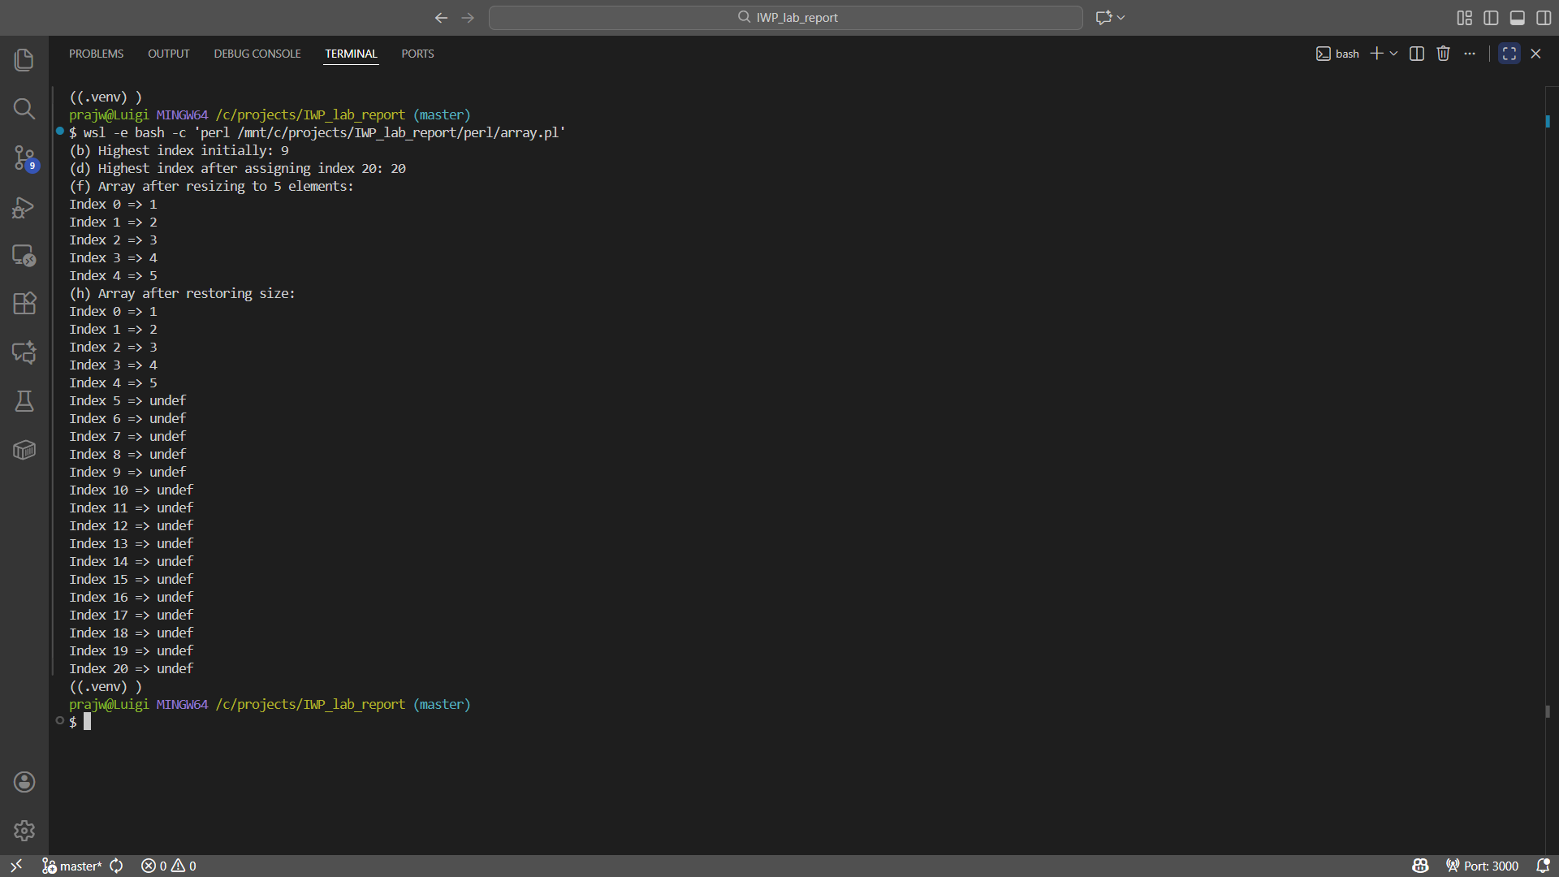
Result: Thus the program is executed and output is verified.

